
DE10 Audio Game
SWE-350
11/9/2025

Nolan Tuttle
Grand Canyon University
College of Engineering and Technology
Software Engineering Program
Embedded Systems 1

Table of Contents
Project Demonstration Link……………………………………………………………………………………2
Github Repo Link………………………………………………………………………………………………………2
System Design……………………………………………………………………………………………………………3
Application Logic Design………………………………………………………………………………………….7
Risk Matrix…………………………………………………………………………………………………………………11
Test Plan………………………………………………………………………………………………………………………12
Known Issues………………………………………………………………………………………………………………13
Misc Documentation…………………………………………………………………………………………………14

Project Demonstration Link

https://youtu.be/mlHy81LQRwI

GitHub Repo Link
https://github.com/nolantuttle/DE10AudioGame

System Design
General Technical Approach:
This project is an audio-based memory game running on Intel’s SoC FPGA platform. Running on the DE10 Standard embedded board, it maps the four buttons to four unique audio samples and generates a sequence of these audio samples to play from the WM8731 audio codec through the line out port on the board. The goal of the player is to press the buttons which are mapped to the four audio samples to generate the same sequence of audio samples output by the board, with each round the sequence will increment by 1, increasing difficulty of the game. By utilizing both the Hard Processing System (HPS) and FPGA fabric, the application delivers a responsive interaction that combines audio, button input, and hex display feedback.

The HPS is responsible for executing the game logic features of this application. For example, the audio sample sequence generation/randomization as well as keeping track of sequence length. The HPS will check to see if the user’s button input is correct and matches the sequence, if not it is also responsible for resetting the game upon failure. The HPS communicates the audio samples to play over the lightweight AXI bridge into the FPGA’s memory mapped I/O.

Audio output is configured using an I2C line connected to the FPGA and HPS, although the HPS only is responsible for the actual configuration. The output is set to operate in 16-bit I2S mode at 48 kHz so that it is prepared for audio input from the FPGA over I2S. The audio codec functions in slave mode, allowing the clock cycles to be set by the FPGA through its VLSI logic. Game progress and feedback such as current sequence length is displayed on the hex display.

Development of HPS logic such as C files was performed using Visual Studio Code, while compilation, linking, and running occurs through a Makefile-based build system. The structure of the project is modular and separated into sections in the filesystem as shown in Figure 10.

System Design

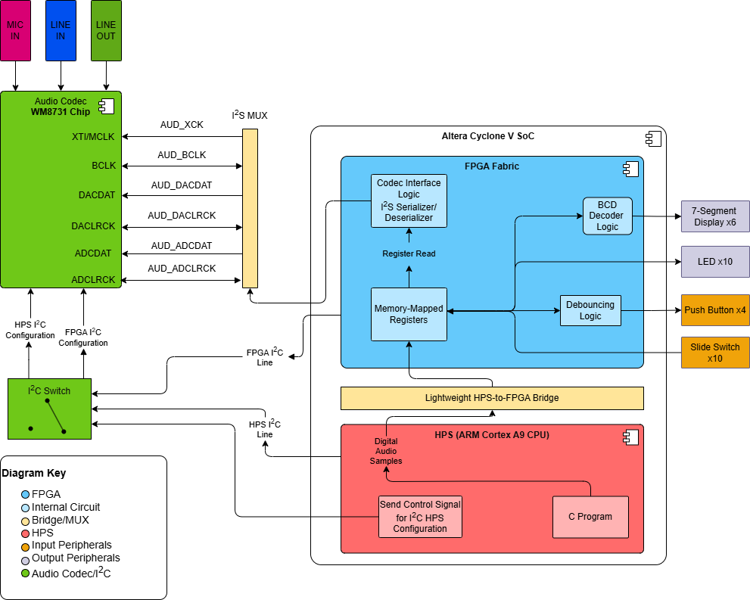

Figure 1: System Design Component Diagram for audio output

Application Logic Design

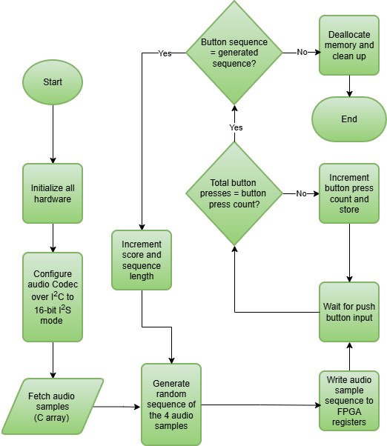
Figure 2: Application Logic Design for HPS
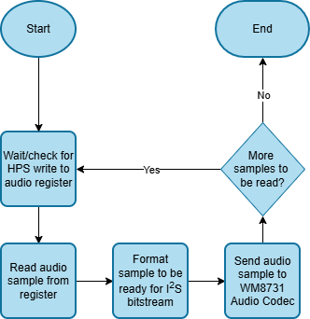
Figure 3: Application Logic Design for FPGA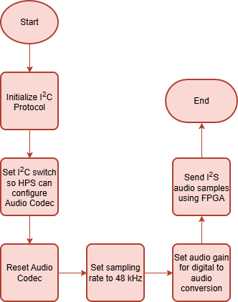
Figure 4: Application Logic Design for Audio Codec
Figure 5: Main Application Pseudocode Logic
START
// Initialize all hardware
Init_hardware()
Configure_codec(bit_depth, sampling_rate, gain)

// Game tracking variables
Sequence = []
Pattern_length = 1
Game_over = FALSE

WHILE !(Game_over)

New_sample = generate_sample()
Sequence.append(new_sample)

FOR sample IN Sequence
Sample_to_FPGA(sample)
Wait_for_playback()
END FOR
// User input
FOR num IN pattern_length
Input = read_button()
If(Input != sequence[num])
Game_over = TRUE
BREAK
END IF
END FOR

IF NOT Game_over
Pattern_length+=1
END IF
END WHILE

Game_complete_display()
END

VLSI Design
Module hps_to_fpga ( // This is for using the HPS to write to the FPGA registers for left and right audio
Input clk, // FPGA system clock
Input rst, // For reset
Input [15:0] hps_sample_left, // Audio sample for the left channel, 16-bit
Input [15:0] hps_sample_right, // Audio sample for the right channel, 16-bit
Input hps_data_ready, // Flag from HPS for when new data is ready
Output reg [15:0] sample_left, // Current sample register to be sent for left side
Output reg [15:0] sample_right, // Current sample register to be sent for right side
Output reg sample_ready // Signal for I²S module that new data is ready
);

Always @(posedge clk or posedge rst) begin // This executes when on the rising edge of the clock
// Or when the reset goes high, acting as a flip-flop

If(rst) begin // If reset is high, set everything to zero and clear sample_ready
Sample_left <= 16’b0
Sample_right <= 16’b0
Sample_ready <= 1’b0
End
Else if (hps_data_ready) begin
Sample_left <= hps_sample_left
Sample_right <= hps_sample_right
Sample_ready <= 1’b1
End
Else begin
Sample_ready <= 1’b0
End
End
Endmodule
Figure 6: HPS to FPGA Register Write Verilog Logic Outline
Module 12s_transmission (
Input clk, // FPGA clock
Input rst, // For reset
Input [15:0] sample_left, // Left side sample
Input [15:0] sample_right, // Right side sample
Input sample_ready // Flag for when the sample is ready
Output reg i2s_sck, // Serial clock for audio codec
Output reg i2s_ws, // Word select (left/right)
Output reg i2s_sd // Serial audio data

Reg [4:0] bit_count // 0-15 for 16-bit samples
Reg [15:0] shift_register
Reg current_channel // 0 for left, 1 for right

Reg [7:0] sck_div // Clock divider counter (increments each time FPGA clock ticks)
// We use this to
Always @(posedge clk or posedge rst) begin
If(rst) sck_div <= 0
Else sck_div <= sck_div + 1
End
Always @(posedge clk) i2s_sck <= sck_div[7] // Output clock frequency is <= frequency at sck_div[7]

// We use the clock divider because the FPGA base clock is 50 MHz. Therefore, to set sampling rate
// to the desired 48 kHz, we divide it down by a power of 2 each bit of sck_div, sck_div[4] is
// approximately 1.56 MHz, where 1.536 MHz is the desired output frequency.
// We get 1.536 MHz from the desired 48kHz sampling rate in the configuration, multiplied
// by the 16 bit sample size and the 2 channels for left and right sides.
// This edge trigger logic is for shifting into the shift register
Always @(negedge i2s_sck or posedge rst) begin
If (rst) begin // Reset condition
bit_count <= 0;
shift_register <= 16'b0;
current_channel <= 0;
i2s_ws <= 0;
i2s_sd <= 0;
End

Else begin
If (bit_cnt == 0) begin
// Load new sample at start of channel
Shift_reg <= current_channel ? sample_right : sample_left;
I2s_ws <= current_channel;
Current_channel <= ~current_channel;
End
Else begin
// Shift out next bit
Shift_register <= {shift_register[14:0], 1'b0};
End
i2s_sd <= shift_register[15];
Bit_count <= (bit_count + 1) % 16;
End
End
Endmodule
Figure 7: I2S Line Data Transmission Verilog Logic Outline

Risk Matrix
ID | Category | Description | Severity | Mitigation
1 | Scope | The audio I2S pipeline from the C program on the HPS to the audio codec is highly complex, so there is a risk of faulty system design resulting in functional issues or system failure. | H | Reduction - Mirror existing official documentation from Terasic, conduct extensive research on communication protocols like I2S and I2C, as well as the WM8731 audio codec.
2 | Technical | Because setting the clock rate for the codec is done using the clock division method (shown in Figure 7), the FPGA clock division might not match the sample rate needed for the codec. | M | Reduction - Adjust the FPGA clock division in the FPGA Verilog logic.
3 | Technical | When configuring the audio codec over I2C using the HPS, an incorrect configuration (wrong sampling rate, gain, etc.) (see Figure 4), can cause prevented audio output. | M | Reduction - Validate the correct register writes happen over I2C, test with a known audio codec configuration.
4 | Technical | The FPGA must be configured in such a way that the HPS only sends data when it is ready to receive data in its registers. There is a risk that these are not in sync with each other and data is sent when FPGA is not ready. | H | Avoidance - Use a handshaking method between HPS and FPGA, something like the flag hps_data_ready in the Verilog logic (Figure 6).
5 | Operational | Latency in audio playback or peripheral responsiveness may hinder UX when running the game. | L | Acceptance -Replace more HPS logical operations with FPGA programming to improve latency.

Test Plan
# | Title | Summary | Steps | Data | Expected  Result | Status
1 | FPGA Button IRQ interaction | Verify that the interrupt request module for the pushbutton works properly | - Power on board  - Load the kernel module (irq_pushbutton.ko)  - Push any button  - Verify LED feedback | The analog data from the button press being passed to the HPS. | The LEDs should increment their binary count representation with each consecutive button press. | Pass

Known Issues
ID | Description | Plan of Address
1 | N/A | N/A

Misc Documentation
One important aspect to understand about the I2S communication between the FPGA and the audio codec chip in this project is that, unlike a system where the codec chip works as a master, determining the necessary clock cycles for itself, it is better in this application for the audio codec chip to be in slave configuration, letting the FPGA generate the necessary clocks. The two clocks here are the serial clock (sck) and word select (ws) pictured below in Figure 8 and as used in the Verilog logic in Figure 7. Figure 8 shows a block diagram for what the shift register that receives the audio data might look like with a master codec design. Note that the below diagram is a master configuration, not slave configuration.
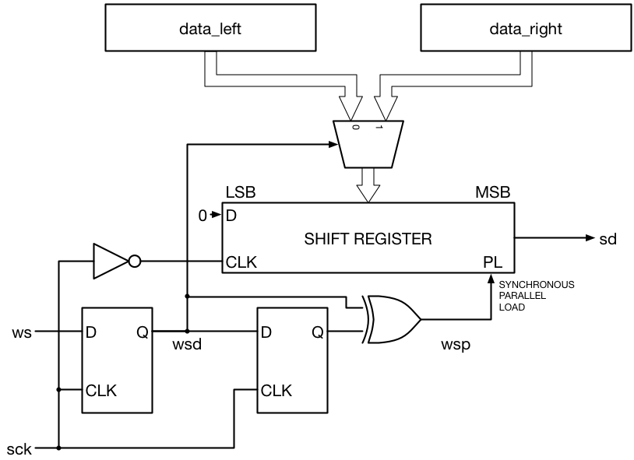
Figure 8: Traditional I2S transmitter block diagram. Reprinted from Beyond Circuits, "Tutorial 19: I2S Transmitter," https://www.beyond-circuits.com/wordpress/tutorial/tutorial19/.

Using a master configuration as shown above in this embedded application could result in inaccurate audio samples because there is a risk of generating inaccurate frequencies since it is handled by the codec. The bigger risk here, however, is synchronizing the FPGA clock with the WM8731 Codec clock. If the FPGA handles the clock generation, such as in a slave design, the FPGA has full control over timing, shown by the FPGA clock S_AXIS_ACLK shown in Figure 9. This makes it far easier to synchronize HPS audio sample writes to FPGA registers that will output audio; however, the FPGA must generate accurate clocks. This is an important distinction because it affects the Verilog significantly; the FPGA must generate clocks and thus, requires modules that can help the system function in slave mode.
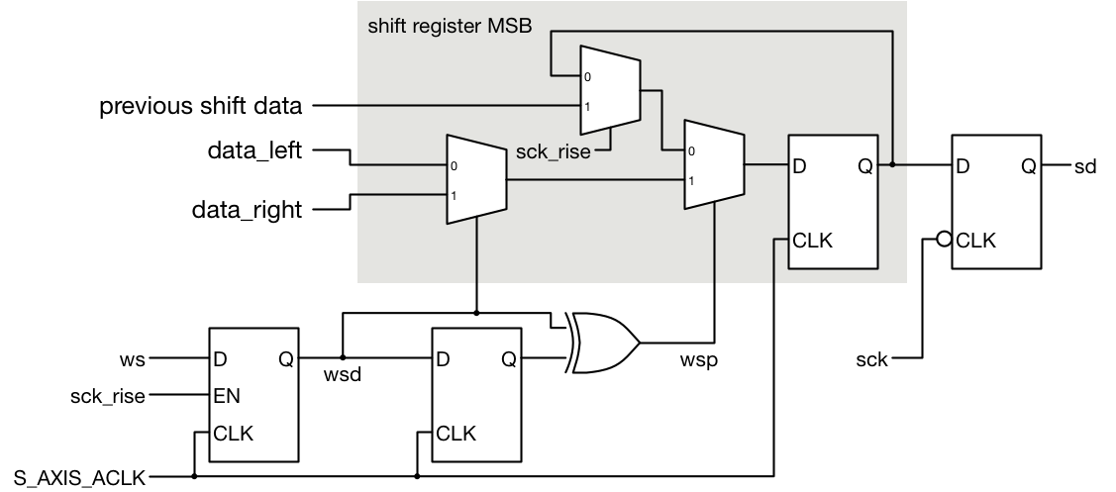
Figure 9: FPGA Clock I2S transmitter block diagram. Reprinted from Beyond Circuits, "Tutorial 19: I2S Transmitter," https://www.beyond-circuits.com/wordpress/tutorial/tutorial19/.
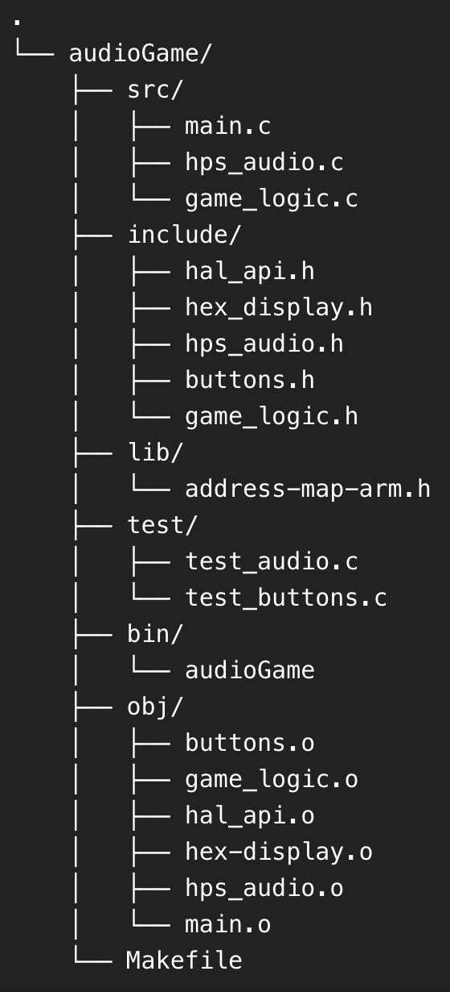
Figure 10: File Tree Structure for Audio Game project

Reference
Beyond Circuits. (n.d.). Tutorial 19: I2S Transmitter. Retrieved October 18, 2025, from https://www.beyond-circuits.com/wordpress/tutorial/tutorial19/

